**29th September 2019**

**Finite Element Analysis (FEA) Pipe #6098**

Geometric discontinuities cause a large variation of stress locally and often produce a significant increase in stress. The high stress due to geometric discontinuity (stress concentration) would lead to failure and fracture. This report has been conducted to consider how composite sleeves can reduce stress concentrations and evaluate the possibility of applying those on the current defect (buckle). Prior to starting, knowing the maximum principal stress of the undamaged pipe is essential. General specifications regarding the modeled pipe are presented below (Table 1).

Table 1: Pipe Specifications

|  |  |  |  |
| --- | --- | --- | --- |
| Diameter | Thickness | Length | Material |
| 1219 mm (48”) | 14.3 mm (0.56”) | 3190 mm (125.59”) | X65 |

According to the given information the pipe is under 7.239 MPa (1050 psi) internal pressure. The reaction force of soil to buried pipe has been considered with the information provided.

G:\SHAFAEI\Wrinkle Bends\abaqus\results pic\undamaged\1.tif

Figure 1: Undamaged Pipe Stress Analysis Result

The geometry of the damaged pipe #6098 has been modeled according to the data provided (Table 2). Figure 2 displays how these dimensions were measured.

Table 2: Defect Dimensions

|  |  |  |  |  |  |
| --- | --- | --- | --- | --- | --- |
| **Pipe number** | **Line number** | **Depth (Up)** | **Depth (Down)** | **Length** | **Width** |
| 6098 | 1 | 1 & 1 | 1.95 | 370 | 960 |
| 2 | 6.02 | 5.41 | 400 |
| 3 | 3.31 | 20.79 | 480 |
| 4 | 3.83 | 23.45 | 450 |
| 5 | 4.75 | 16.22 | 480 |
| 6 | 2 | 11.91 | 420 |
| 7 | 0 | 4.02 | 380 |

|  |  |
| --- | --- |
|  |  |

Figure 2: Measuring the Pipe Defect

After modeling the damaged pipe (figure 3), accurate mesh generation is essential in order to obtain precise results. As it can be seen (figure 3) tiny tetragonal elements (total number of 190,697) were created for this model in order to obtain a more accurate result.

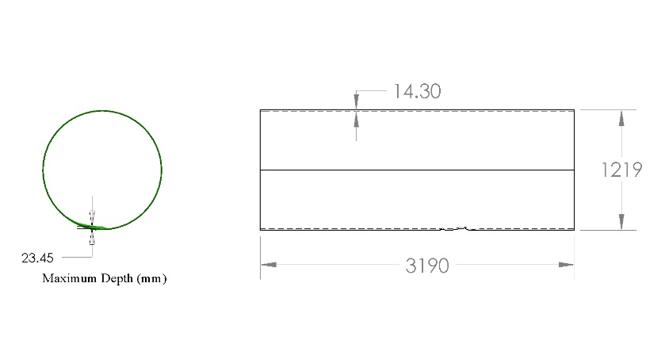

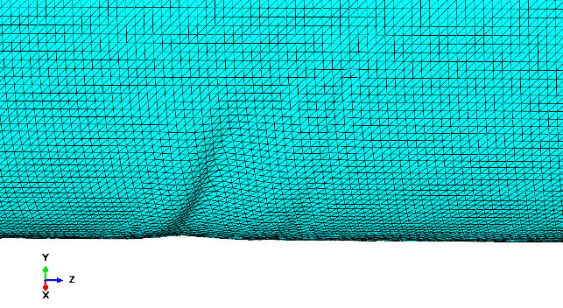

Figure 3: Mesh Generation

As it can be anticipated, the maximum principal stress happened in the defected zone (figure 4). The maximum principal stress for this zone is about 459.2 MPa, which is colored in red in the revealed contour.

G:\SHAFAEI\Wrinkle Bends\abaqus\results pic\damaged\2.tif

Figure 4: Damaged Pipe Stress Analysis Result

Filling the damaged area with filler material and then covering it by two Clock Spring composite sleeves with a width of 305 mm and thickness of 13 mm, promising results were achieved (figure 5). The line contour of this stress for damaged area before and after installing composite sleeves are presented (figure 6). Clearly, the defected regions were soundly fixed after utilizing composite sleeves. Moreover, stress distribution in composite sleeves is also presented (figure 7). Nearly, 44.8 MPa was tolerated by the composite sleeves which was in the location of buckle.

G:\SHAFAEI\Wrinkle Bends\abaqus\results pic\reinforced\1.tif

Figure 5: Stress Analysis Result Reinforced by Clock Spring Composite Sleeves

G:\SHAFAEI\Wrinkle Bends\abaqus\results pic\damaged\6.tifG:\SHAFAEI\Wrinkle Bends\abaqus\results pic\reinforced\2.tif

(1) (2)

Figure 6: Line Contour in Damaged Area Before (1) and After (2) Repair

G:\SHAFAEI\Wrinkle Bends\abaqus\results pic\reinforced\5.tif

Figure 7: Stress Distribution in Composite Sleeves

Taking the undamaged pipe (figure 1) into account, it is obvious that the maximum principal stress in damaged pipe increased by nearly 33 percent, from 311.2 to 459.2 MPa. Comparing figure 4 and 5 reveals that the effect of installing composite sleeves is satisfactory, reducing the maximum principal stress to approximately 26% from 459.2 MPa in damaged pipe to 336.5 MPa.

The yield strength of X65 material is in the range of 448-600 MPa. The maximum principal stress occurred in the damaged pipe was 459.2 MPa which could pose a threat to the pipe as it would lower the safety factor criteria. Therefore, Clock Spring® composite sleeve is solution that will extend the lifetime of the defect by many years.

Prepared by:

Rohollah Shafaei